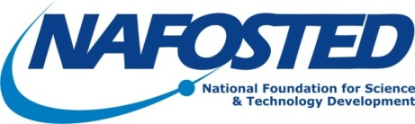

Date… Month… 2016
Mr.
[Title]
[Company/Foundation]
[Address]

Dear Mr….,

[Company/Foundation] - NAFOSTED Scientific Conference
[Date/Time], Ha Noi, Vietnam
I am writing on behalf of the National Foundation for Science and Technology Development (NAFOSTED) to officially invite you to participate in the networking Symposium between National Health and Medical Research council of Australia (NHMRC) and NAFOSTED. As you may know, this Symposium serves the purpose of building linkages and identifying research themes between health and medical research of two sides. In addition, the conference opens the possibility of potential research collaboration in the near future.
This meeting will be organized by NAFOSTED and take place from 29th to 30th November 2016 in Ha Noi, Viet Nam. The financial support provided and administered by NAFOSTED will cover domestic travel associated with your participation in this meeting.
We are pleased that you will be able to participate in this meeting and look forward to greeting you in Ha Noi.
With best regards,

[Director/Deputy Director]
National Foundation for Science and Technology Development

